**Experiment-10**

**STEP 1: Create a new Directory.**



2)Create a main.tf to store the config files of terraform

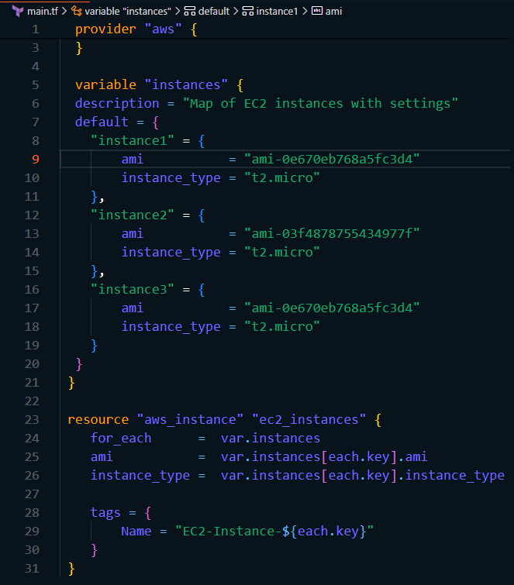

3)Run terraform init and terraform apply

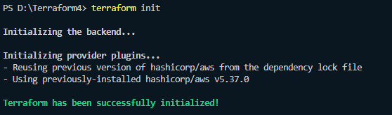

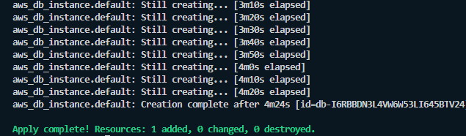

4)Check the aws rds dashboard



5)Run terraform destroy to clean up all the resources

